Best speech to text applications

<https://www.computerworlduk.com/galleries/applications/best-speech-text-software-3675066/>

1. Dragon

Nuance’s [Dragon Naturally Speaking](https://www.nuance.com/en-gb/dragon.html) (DNS), also known as Dragon for PC, is speech recognition software available in eight languages. It claims a 99 percent accurate speech to text transcription and is recognised as one of the most accurate pieces of software on the market.

DNS includes voice commands which enable users to format and edit text using voice, with the addition of custom commands for computer actions and transcribing files. It can be run on Windows and Macs, as well as iOS and Android devices.

DNS integrates its voice commands and editing features together to ensure the text is provided just as the user delivers the speech, with specific punctuation and formatting options inserted upon command by the speaker.

The newest version of the software, DNS 13, is available in home, premium and professional editions, with the latter allowing users to import and export custom word lists to add any specific words and acronyms that may not already be in the vocabulary.

Nuance charges £79.99 for its Home Edition, £125.99 for premium and the professional edition starts at £279.99.

LinkedIn

Google Plus

As voice recognition technology has evolved, speech to text and transcription software has come on leaps and bounds.

This software has wide-ranging applications, from assisting people with disabilities, helping people learn languages, as well as being a god send to journalists tasked with transcribing long interviews.

Here we examine some of the best speech to text software available right now.

**Read next:** [**Best software tools for journalists**](https://www.computerworlduk.com/galleries/applications/best-software-tools-for-journalists-3673079/)

PrevNext

**2. Transcribe (Wreally)**

+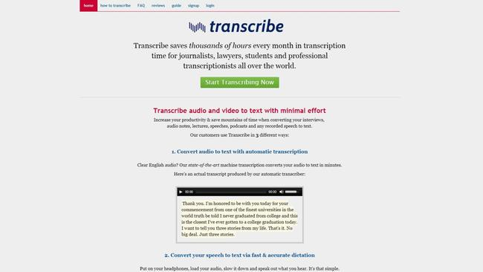

**2**/**9**

Play / Pause

PrevNext

The name gets poor marks for imagination, but it does convey the clean functionality with which [Transcribe](https://transcribe.wreally.com/) converts your (clear, English) audio into text.

The automatic transcriber effortlessly converts your recordings into written text files. However, if your sound quality isn't clear, you can also slow the text down and read it aloud, and the software will capture what you're saying - for a range of languages.

As a last resort, you can use the application to support manual transcribing, by playing the sound file within the software and employing a number of useful controls to streamline the process.

The basic self-transcribe package comes in at $20 (£15) per year (although if only opting for this, there are free alternatives such as oTranscribe out there) and $6 (£4.50) per 60 minutes of automatic transcription.

Google Plus

As voice recognition technology has evolved, speech to text and transcription software has come on leaps and bounds.

This software has wide-ranging applications, from assisting people with disabilities, helping people learn languages, as well as being a god send to journalists tasked with transcribing long interviews.

Here we examine some of the best speech to text software available right now.

**Read next:** [**Best software tools for journalists**](https://www.computerworlduk.com/galleries/applications/best-software-tools-for-journalists-3673079/)

PrevNext

**3. IBM Speech to text**

+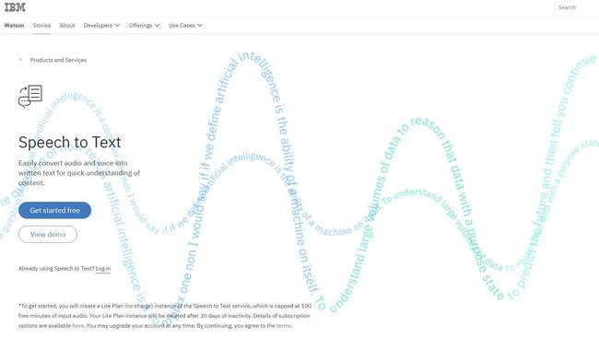

**3**/**9**

Play / Pause

PrevNext

You can trial IBM's Watson-powered [speech to text service](https://www.ibm.com/watson/services/speech-to-text/) for free on their Lite Plan, which allows for up to 100 minutes of free audio input per month. The full package offers automatic real-time transcription for seven languages, even for lower quality audio with powerful speech recognition technology.

You can customise the service to recognise particular product or peoples names, for example. This software is designed to be adaptable and scalable for many different use cases spanning from real-time transcription from a microphone to analysing thousands of recordings from your business's call centre.

If you need to go beyond a Lite Plan, a Standard plan offers the first 1000 minutes free, and after that, between one and 250,000 minutes are charged at $0.02 (£0.015) per minute.

**. Amazon Transcribe**

+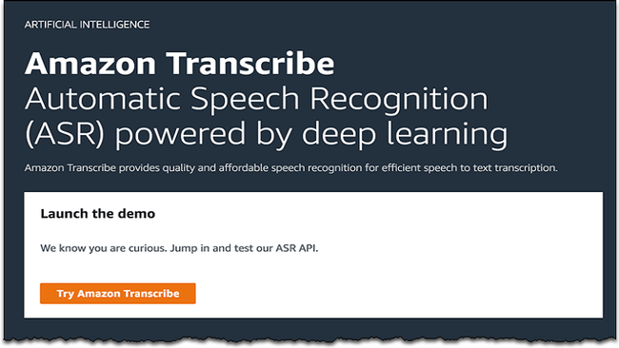

**4**/**9**

Play / Pause

© Amazon AWSPrevNext

[Amazon Transcribe](https://aws.amazon.com/transcribe/) is an automatic speech recognition service which is powered by deep learning. It is best suited for developers that may want to add speech-to-text to their apps.

It can also be used to transcribe audio and video files, including a detailed transcript of customer service calls. This makes it a good choice for businesses that may need to transcribe client meetings.

The built-in API is simple to use and provides a quick transfer of transcripts from files stored in Amazon S3. It also includes a timestamp for each word, as well as the opportunity to customise vocabulary to add any new words or acronyms that may not be in there already.

Amazon Transcribe provides a free tier of 60 minutes a month for one year, following that the pricing is $0.0004 (£0.00028) per second.

**5. Temi**

+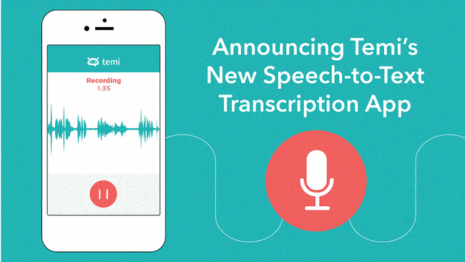

**5**/**9**

Play / Pause

© TemiPrevNext

[Temi](https://www.temi.com/) uses automated software to provide a detailed speech to text transcription in five minutes.

The app allows users to make recordings, edit and share them with the ability to order transcripts. It is available on Apple’s app store and Google Play for free download.

Transcripts are priced at $0.10 (7p) per minute. This includes custom timestamps, speaker identification and the opportunity to export transcripts to MS Word and other formats directly from the app. Temi also delivers transcripts directly to the user's email.

**6. Windows speech recognition**

+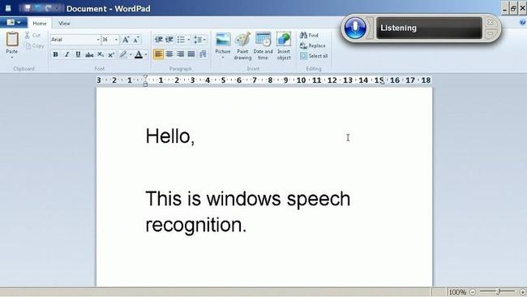

**6**/**9**

Play / Pause

© YouTubePrevNext

[**﻿**Windows Speech Recognition](https://support.microsoft.com/en-gb/help/17208/windows-10-use-speech-recognition) (WSR) offers speech recognition for Microsoft Windows Vista and later.

The speech to text feature allows users to dictate text within documents and email messages. It is available in eight languages including UK/US English, Chinese, and Spanish.

The accuracy of WSR is best with good-quality audio. As it is automatically built into the Windows OS, there is no additional price to access the speech recognition software.

However, compared to other speech to text platforms, WSR users will need to select a 'play audible feedback' option after the transcribed text is selected to ensure accuracy.

**7. Speech Recognition SoundWriter**

+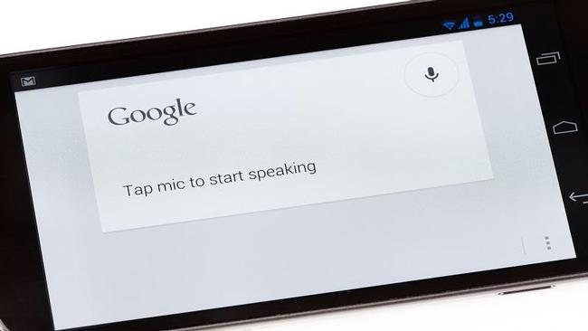

**7**/**9**

Play / Pause

© iStockPrevNext

[Speech Recognition SoundWriter](https://chrome.google.com/webstore/detail/speech-recognition-soundw/idmniglhlcjfkhncgbiiecmianekpheh?hl=en) is a voice typing and recognition software addon for Google Docs.

As long as users have a microphone installed, SoundWriter can be used to write all Google Doc files in any language. It also includes custom configuration, which provides the opportunity to add words as commands, as well as any specific characters and punctuation styles.

Although the addon only works with the Google Chrome browser, SoundWriter can be a good option for regular users of Google Docs. It also has voice typing integrated and is available for free download.

Facebook

LinkedIn

Google Plus

As voice recognition technology has evolved, speech to text and transcription software has come on leaps and bounds.

This software has wide-ranging applications, from assisting people with disabilities, helping people learn languages, as well as being a god send to journalists tasked with transcribing long interviews.

Here we examine some of the best speech to text software available right now.

**Read next:** [**Best software tools for journalists**](https://www.computerworlduk.com/galleries/applications/best-software-tools-for-journalists-3673079/)

PrevNext

**8. Google Docs Voice Typing**

+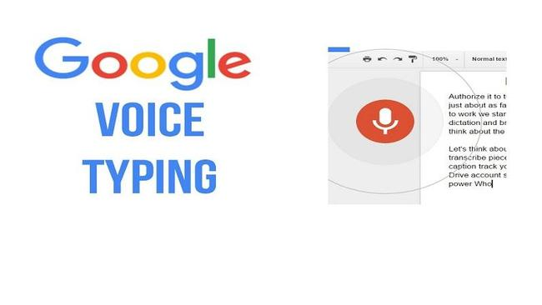

**8**/**9**

Play / Pause

© YouTubePrevNext

[Google Docs Voice Typing](https://support.google.com/docs/answer/4492226?hl=en) provides web-based dictation and speech recognition for Google Docs users, particularly for those that may only require the speech to text feature across their Google Suite platform.

It can be accessed in 43 different languages for voice typing, but voice commands are only available in English. It is free to install to the Google Chrome web browser.

It is easy to use as clicking on the microphone icon controls start and stop of dictation and all delivered speech is transcribed directly as you speak. So, it is a good option for instant transcription of client meetings and recordings.

With the added commands, Google Docs Voice Typing follows instant instructions to delete or edit text as it is commanded.

PrevNext

**9. Trint**

+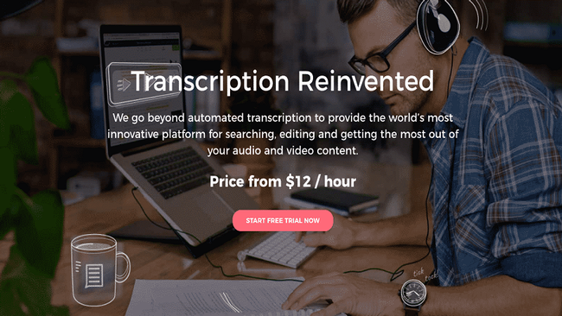

**9**/**9**

Play / Pause

© TrintPrevNext

[Trint](https://go.skimresources.com/?id=91802X1545673&xs=1&isjs=1&url=https%3A%2F%2Ftrint.com%2F&xguid=c3cba5fb714961a9e1a020dfabe08c96&xuuid=bd630df16111b5ecf62526fa2599442e&xsessid=&xcreo=0&xed=0&sref=https%3A%2F%2Fwww.computerworlduk.com%2Fgalleries%2Fapplications%2Fbest-speech-text-software-3675066%2F&pref=https%3A%2F%2Fwww.google.com%2Furl%3Fsa%3Dt%26rct%3Dj%26q%3D%26esrc%3Ds%26source%3Dweb%26cd%3D2%26ved%3D2ahUKEwjxr5_2_4rfAhWFlYsKHS3XDC8QFjABegQIBRAG%26url%3Dhttps%253A%252F%252Fwww.computerworlduk.com%252Fgalleries%252Fapplications%252Fbest-speech-text-software-3675066%252F%26usg%3DAOvVaw1JF_EEdSgkdxTQ4iULJrlR&xtz=-120&jv=13.12.1-stackpath&bv=2.5.1) is speech to text transcription software which provides automatic transcripts of audio and video files using artificial intelligence.

Users can access a quick search and edit feature that is embedded into the software to ensure detailed accuracy. The software also makes it easy to share and collaborate transcribed content, so a good choice if working in a team.

It is available in 12 languages, plus three English accents. There are three price plans available for Trint, these are pay as you go at £13.20 an hour, basic at £26 a month and supercharged at £100 a month.

The pay as you go plan provides unlimited credit for 12 months, the basic plan offers three hours a month and supercharged provides 10 hours a month.

5 leading apps to study English

<https://www.educationalappstore.com/best-apps/5-best-apps-for-english-language-learners>